Parts is Parts
a mixed media class with artist and author, Mary Beth Shaw
Imagine working loose and free, with no thought toward an outcome. You don't have to worry about composition, subject matter or anything at all. Just enjoy the process of art making and creative play. That's what we are gonna do in Parts is Parts.

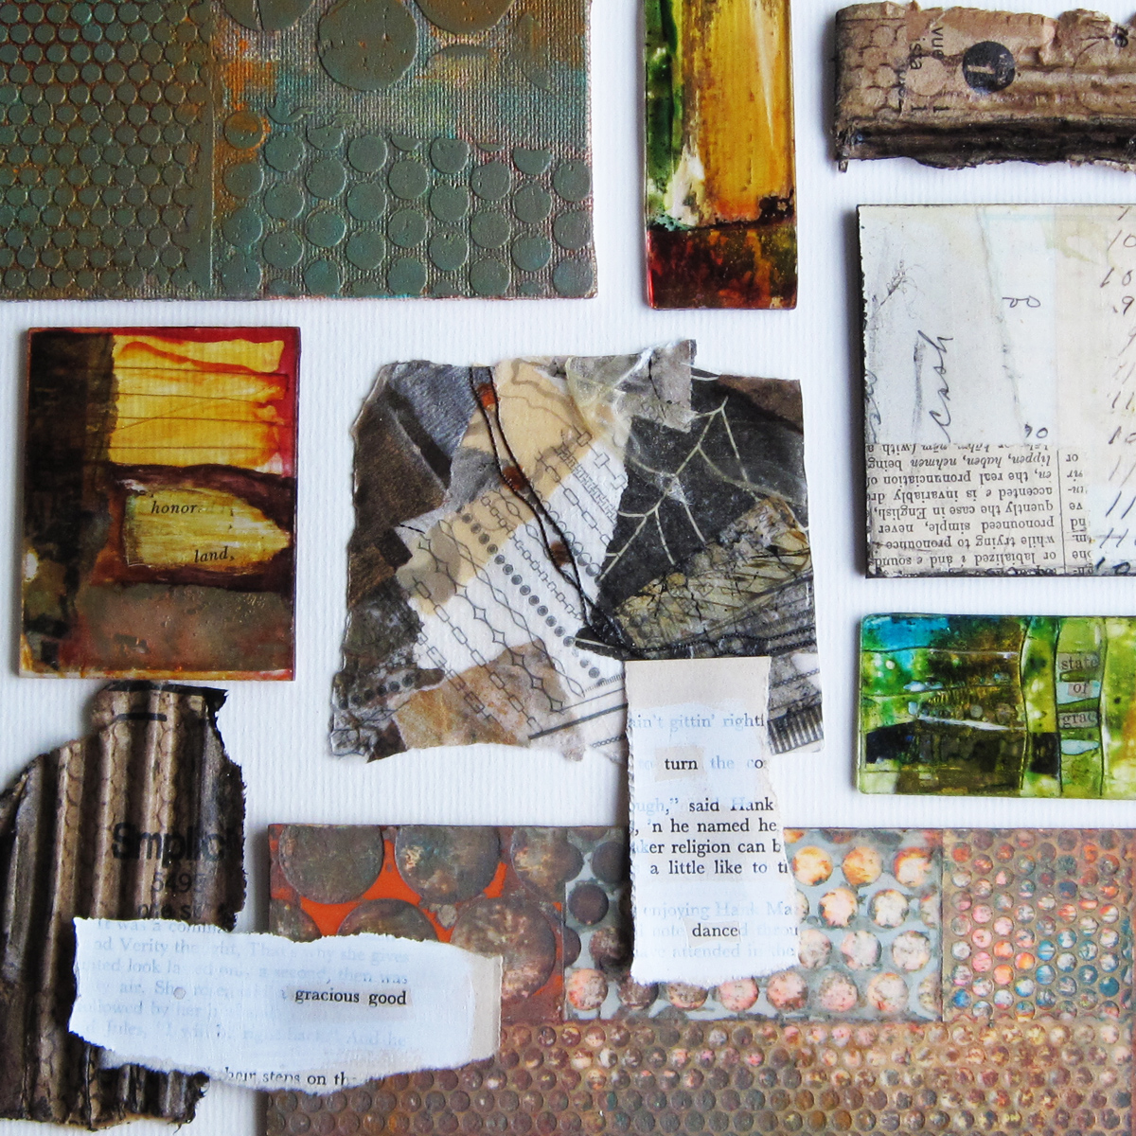

March 12th from 12-4

Loosely following some of the techniques in my book, while also replicating how I work in the studio, I will teach you to multi-task in such a way that you don't even realize you are doing it. You will learn to switch back and forth from one item to the next, covering lots of ground in the process. Our day will start with making a Collagraph Plate then move to Crazy Paper then to Text Block and Cardboard Cutouts and Plexi Pieces.
While one thing dries, we navigate to the next, and then the next and so on. Eventually we will find our way back to those Collagraph plates and pull some lovely prints.

By the end of the day you will have prepared all sorts of 'parts' to include in your library of supplies. You can use them in your future projects ranging from greeting cards to mixed media collage paintings.

Rock Paper Scissors call (636) 724-5002 to register
$50 includes everything you will need but be prepared to get messy (gloves & apron encouraged)

